Practical - 7
Practical Title: PHP Form Processing with Server-Side Validation and CSV/JSON File Storage

Process submitted registration/contact form data using PHP. Validate and sanitize inputs on the server side and store records in CSV or JSON file format. Display success/error messages.

Theory

1. Is the form submitted using POST?
- Yes, the form is submitted using the POST method.
- POST is used to send form data securely to the PHP backend.
- The submitted data is not displayed in the URL.

2. Are inputs validated and sanitized server side?
- Yes, inputs are validated on the server side using PHP.
- Required fields are checked before processing.
- Email format and other input formats are validated.
- Input data is sanitized to remove unwanted or harmful characters.
- Prepared statements are used when inserting data into MySQL to prevent SQL injection.
- Invalid or duplicate inputs are rejected with an appropriate error message.

3. Is file writing handled safely?
- Yes, file writing is handled safely.
- Data is read from external JSON files using the Fetch API.
- The application does not directly overwrite or modify the original JSON files.
- User input is only used for search, filtering, sorting, and pagination.
- Proper error handling is used if the JSON file cannot be loaded.

4. Are success and error responses displayed clearly?
- Yes, success and error responses are displayed clearly.
- Success messages confirm that the operation was completed successfully.
- Error messages clearly indicate what went wrong.
- Messages are displayed directly on the webpage for easy understanding.
- The responses help users identify whether their action was successful or needs correction.

Implementation/ Output/Result

My learning codes: https://drive.google.com/file/d/1CPP3uUq3gdKZxC3pFB7iheZVU7FCImSx/view?usp=drive_link

Evidence of Work (Screenshots)
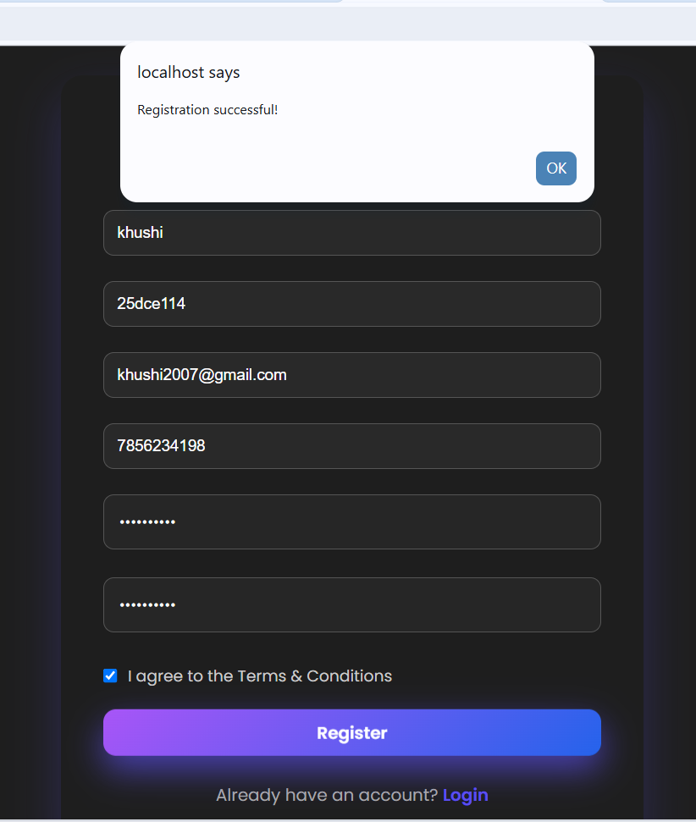
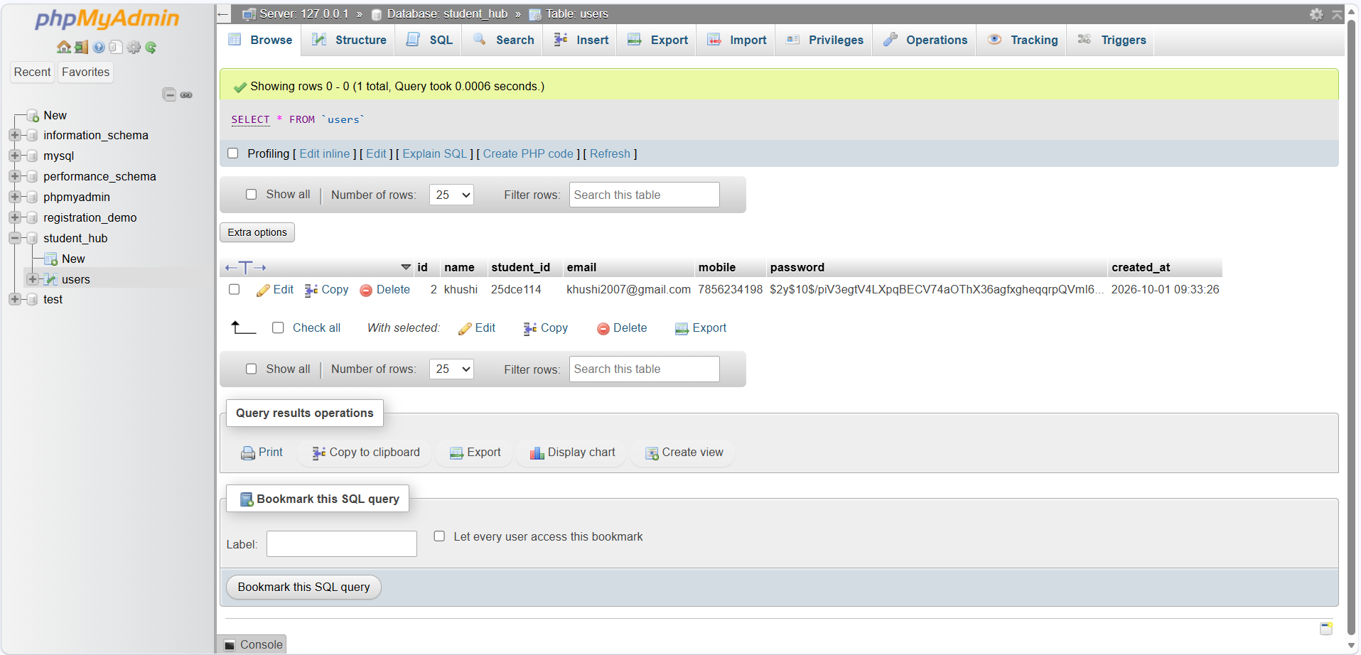
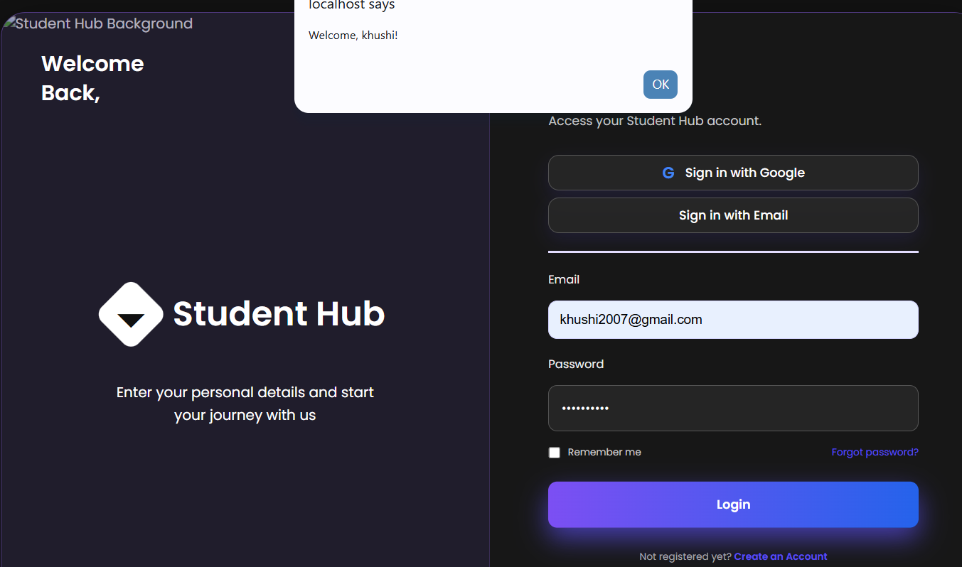

GitHub Repository Link:
Khushi-Thakor2007/Student-Hub-Portal

Challenges Faced:
I faced problem with connecting the database with html file.

Learning Outcomes:

I learned database connections and how the data store in database in local server.

Faculty Remarks:

